 | Town of Chatham  Office of the Select Board Town Manager  549 Main Street  Chatham, MA 02633 | 
Jill R. Goldsmith  TOWN MANAGER  jgoldsmith@chatham-ma.gov |  | Tel: (508) 945-5105  Fax: (508) 945-3550  www.chatham-ma.gov

NEWS RELEASE

FOR IMMEDIATE RELEASE – March 1, 2024

Media Contact:
Robert Faley, Director of Public Works
Town of Chatham
(508) 945-5155
rfaley@chatham-ma.gov

Sewer Construction Update

Chatham – C.C. Construction, Inc. will be continuing work for the Phase 1D-2A: Route 137 – Morton Road Sewer Extension Project (1D-2A) and for the Queen Anne Pumping Station (QAPS) Upgrade as outlined below. Dig It Construction LLC will be continuing work on the Phase 1E-2 – Stage Harbor Road Sewer Extension Project (1E-2).

Work for the week of March 4th – March 8th:
1D-2A:
- Continued site work at Pump Station #3 (Meetinghouse Road) and Pump Station #4 (Twine Field Drive) is expected.

QAPS:
- Site work at the pump station site (40 Queen Anne Road; south side of Queen Anne Road and Oyster Pond Furlong intersection).

1E-2:
- Continued site work is expected at the pumping station site (Old Mill Boat Yard/Harbormasters Garage) and sewer work along Stage Harbor Road.
- Continued sewer lateral installation on Honeysuckle Lane, Cedar Swamp Lane, and Atwood Lane. For public safety reasons, Stage Harbor Road between the Harbormaster’s Garage and Bridge Street will be closed and a detour will be in place.
  - The detour route will be from Bridge Street North to Stage Harbor Road, to Cedar Street, to Champlain Road.
  - The detour route from Champlain Road will be to Cedar Street, to Stage Harbor Road, to Bridge Street.
  - See figures below for additional information for WORK ZONE 1

Two Week Look Ahead (3/11 – 3/15):
1D-2A:
- Continued site work at Pump Station #3 (Meetinghouse Road) and Pump Station #4 (Twine Field Drive) expected.
- Tentative - Sewer work at the Chatham Water Pollution Control Facility (WPCF).

QAPS:
- Site work at the pump station site (40 Queen Anne Road; south side of Queen Anne Road and Oyster Pond Furlong intersection).

1E-2:
- Continued site work is expected at the pumping station site (Old Mill Boat Yard/Harbormasters Garage) and sewer work along Stage Harbor Road.
- Continued sewer lateral installation on Honeysuckle Lane, Cedar Swamp Lane, and Atwood Lane. Stage Harbor Road expected to be closed from Bridge Street to the Harbormasters Garage. Detour will be in place.

Three Week Look Ahead (3/18 – 3/22):
1D-2A:
- Continued site work at Pump Station #3 (Meetinghouse Road) and Pump Station #4 (Twine Field Drive) expected.
- Tentative - Sewer work at the Chatham Water Pollution Control Facility (WPCF).

QAPS:
- Site work at the pump station site (40 Queen Anne Road; south side of Queen Anne Road and Oyster Pond Furlong intersection).

1E-2:
- Continued site work is expected at the pumping station site (Old Mill Boat Yard/Harbormasters Garage) and sewer work/culvert repair along Stage Harbor Road. Stage Harbor Road expected to be closed from Bridge Street to the Harbormasters Garage. Detour will be in place. Tentative overnight road closure on Stage Harbor Road in front of the Harbormaster’s Garage to expedite roadwork this week.

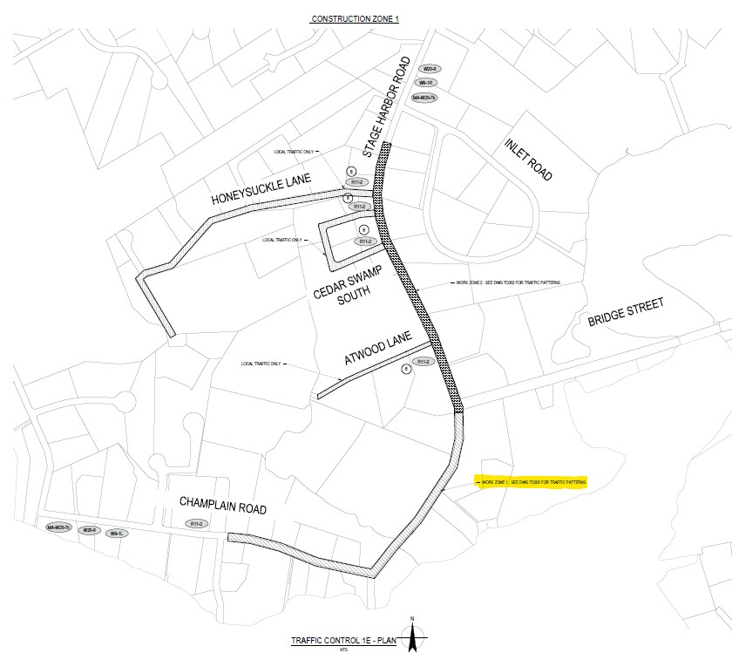

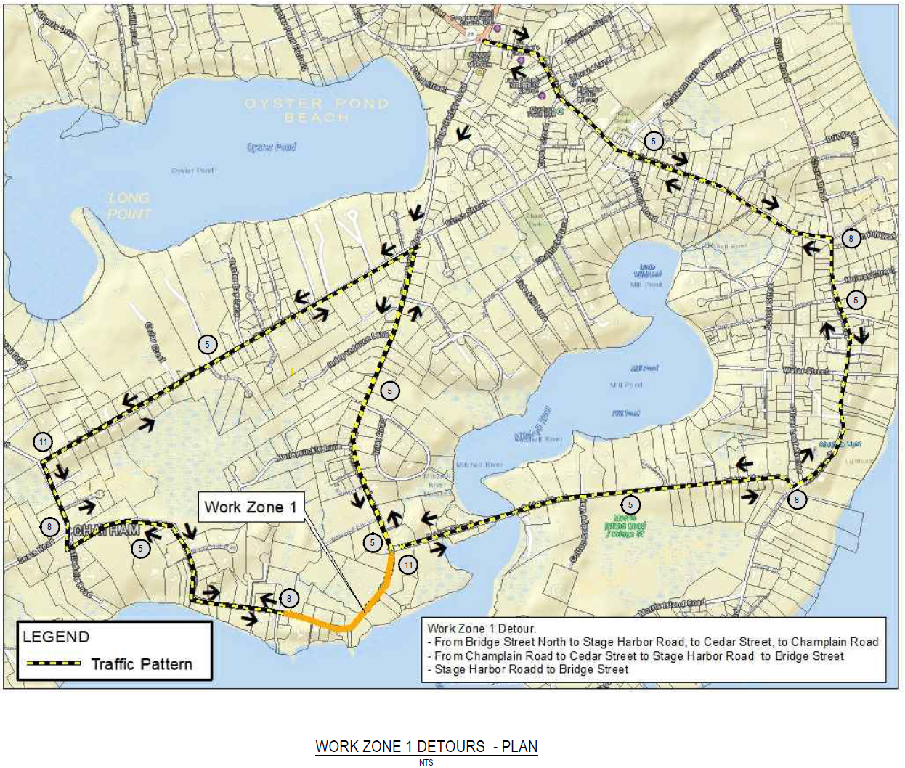
Please note that this is a projected schedule and will be adjusted accordingly based on the Contractor’s actual progress and the weather.

Roads will be passable at the end of each day. Police Details and Contractors will work with residents to ensure their needs for access are addressed.

Police Details and signage will be in-place to assist motorists in reaching their destination.

Normal work hours are 7:00 AM to 4:00 PM Monday to Friday, weather permitting, unless otherwise noted.

The website formerly used for project updates (http://www.chathamscproject.info) is no longer being updated as the information is now available on the Town’s website under the Projects link. If you have this site bookmarked please update with the new link to the Town’s website. Sewer construction updates are being posted to the Town’s website as the primary information site for residents at http://www.chatham-ma.gov. We encourage you to visit for additional information regarding the CWMP and other important projects and events in Town.

Thank you for your patience and cooperation during this important project to restore and protect our environment.

###

