COMMUNITY SERVICES DEPARTMENT
DIRECTOR’S REPORT
MARCH, 2025

SUBMITTED TO: Jill Goldsmith, Town Manager
SUBMITTED BY: Leah LaCross, Director of Community Services

COMMUNITY SERVICES:

March was a very busy month across both divisions of the Community Services Department. All staff members from both divisions continued to work together at bi-weekly meetings to carefully plan out the Center for Active Livings’ (CFAL) potential move to the Community Center should Article 17 - Expansion and Renovation of the Existing Center for Active Living at 193 Stony Hill Road receive a favorable vote by residents.

To date, we have identified the need for new cabinets, refrigerator and dishwasher for the existing warming kitchen on the 3rd floor of the Community Center, so that the Adult Supportive Day Program staff will have an area to prepare meals for participants. Additionally, the need for new furniture in the 3rd floor Club Room was identified by staff. Other issues discussed included the need for additional network wiring in order to support additional staff in the building. While there are many small issues to tackle, we feel that as a collective team, we are in excellent shape in our planning.

On Monday, March 3rd, the CFAL was honored to host the First Annual Team Chatham Employee Art Showcase, presented by the Town of Chatham Employee Engagement and Recognition Committee. Altogether, 7 artists from across Town departments submitted works in a variety of mediums showcasing their incredible talents. Over 40 people attended the Opening Reception, which delighted guests with beautiful artwork and local treats. The works will be in place through April 18th at the Center for Active Living

Chatham’s Recreation and Beaches Division was awarded the 2025 Community Impact Award for the Cape & Islands Region by the Massachusetts Recreation and Park Association (MRPA) on Wednesday, March 19th. This award is made annually to the MRPA member city or town that has provided an outstanding service, program, or event to their community.
Our staff was recognized for the construction of the new pickleball courts, their work with the Friends of Chatham Pickleball, and their focus on special community events throughout the last year.
Congratulations to Aimee Howell, Deputy Director of Community Services, and the entire staff of the Recreation and Beaches Division!

Adult Behavioral Health Clinician:
The month of March had 21 working days in it.
Of the 21 days worked in March, I had 95 interactions with 21 Chatham residents, for a total of 35.8 hours.
Of the 95 interactions:
3 were Center for Active Living (CFAL) outreach visits, which include home visits made at the request of outside referrals.
27 were phone outreach calls, which include calls I made to check in on residents, calls with family members, calls with collateral providers, and calls with medical providers.
1 was a Chatham Fire Department/Emergency Medical Services (CFD/EMS) referral, which included helping an elder get a lock box installed.
11 were client consultations, which means I spoke with other providers within and outside of our town agencies, on behalf of the client.
1 was a co-response call with a Chatham Police Officer. These are carried out when I need to go to the home of a Chatham resident who is either unfamiliar to me and may be unsafe for me to go alone, or for someone who the Chatham Police Department (CPD) is familiar with and insists I go with an officer so that I can safely assess their mental status.
4 were CPD referrals, which include calls that police officers responded to, where the officer feels it necessary for the behavioral health clinician to assess the identified client for possible mental health/substance abuse services or referrals.
3 were CPD well-being referrals, which occurred when the officer gives me a “heads up” on a familiar Chatham resident, and I follow up with the client to make sure they don’t need any behavioral health assistance or support.
2 were CPD referral follow-ups, which means that the identified client is someone CPD has referred to me in the past and I check in on them to make sure they have remained stable.
9 were home visits which are made for those unable to make their way to CFAL or CPD due to physical restraints or transportation issues.
12 were CFAL office visits, which occurred when the resident either had a scheduled appointment with me, or agreed to come to CFAL to discuss how I could assist them.
15 were CFAL incoming client calls, which include the number of calls I received from the Chatham residents asking for assistance.
2 were incoming CPD calls, which includes someone calling into CFAL regarding an elder that may be posing a legal threat to the community.
2 were phone contacts which occur when a Chatham resident calls in looking to meet with the clinician to discuss ideas that fall in the realm of behavioral health.
3 were CFAL follow up outreach, which includes following up either with a phone call or home visit, to a resident that is of concern to a CFAL member.
Community Connections:
This month, I spent 17.5 hours participating in a variety of venues, adding to my pot of knowledge and learning about areas that will enhance my role as the Behavioral Health Clinician for Chatham.
Starting with our monthly staff meetings at CFAL and our planning meetings with the Chatham Recreation staff, both are aimed at making sure staff is identifying areas that need to be addressed, changes that need to be made, and preparing for the possibility that CFAL will be temporarily house at the Recreation Center.
Next, I continue to attend our CCIT (Community Crisis Intervention Team) Meeting in Orleans, where I was able to discuss a case with the team and get feedback and suggestions from the team of first responders, probation officers, recovery coaches, and all the other agencies at the table. The knowledge that all who were present had to offer me was priceless. It is a great opportunity to learn from each other, see how different towns handle situations, and run ideas by the team. The thing I like the most about this group is the connections I am making with my colleagues. Each month I feel more comfortable reaching out to them to ask questions and pick up the phone and call them for advice. It is exciting and rewarding at the same time.
I also attended a presentation on Teen Substance Abuse and Mental Health on Cape Cod, spearheaded by Behavioral Health Innovators of Cape Cod. It was difficult to listen to, but incredibly eye-opening and important to hear. As a clinician who is faced with young adults suffering from substance abuse and mental health struggles, it was raw and honest look at what our youth are facing on Cape Cod. I was able to network with amazing professionals who are boots on the ground, working directly with our youth, giving us an honest look at what they are facing today.
The last event I attended, and the most startling one to date, was the Chatham Police Department Tactical Training I was invited to at the Gannon Training Facility in Yarmouth.
To be honest, when I heard about this training, I thought I would just sit back and watch a movie on guns or watch the officers shoot at a shooting range. Boy was I wrong. I left both days of training feeling both gratitude and admiration for our police officers.
Although I have been on multiple co response calls with the officers, this training gave me a real, raw look through the eyes of the officers of what they face every time they are sent to a home or building for a 911 call. Being a first responder is not for the weak. They are literally putting their lives on the line for our community. They risk their lives EVERY.TIME. they respond to a call.
There were exercises that required me to go into a simulated scene of someone who needs a clinician, while also carrying a weapon and holding someone hostage. Although the officer was on the scene with me, the amount of terror that comes with the unknown is indescribable. I appreciate that the CPD has been thoughtful in their training and are working with our officers to make sure my safety is at the forefront. There were exercises that went step by step with how to handle my presence on a call. The Chief and Deputy Chief are now creating policy around having the clinician present on calls and outlining what is safe and unsafe and policy around where the line is drawn to keep me safe but effective.
Overall, March was a great month of learning and growing.
March Reflection
Family and Caregivers
Have you ever wondered what happens to the family and caregivers who take care of our most vulnerable residents? Who takes care of them? Who follows up with them to make sure they have what they need amid a mental health crisis, or a pending death, or declining health of a loved one?
Whether we are talking about an 80-year-old with Dementia or a 20-year-old with behavioral health issues, the family and/or caregivers have often been an afterthought; Not intentionally, but because we (first responders, myself, recovery coach, CFAL) must get to our “next call.”
This month it became very clear to me that the caregivers need just as much support as the identified client does, but they are not aware that they can ask for help too.
During the month of March, as several of our residents began to deteriorate, their caretakers were now the ones being identified for behavioral health services. Before my position came about, our first responders and CFAL were not inclined to refer the caretakers to a provider because there was not one readily available. But now that my position is part of the structure of our town, CPD and CFAL do an amazing job identifying those who could use support after a family crisis.
In March alone, I worked with a family who had a child who held them hostage. I also worked with the grandchild of one of our elders who flew in from California to care for their grandmother as she is at the end stage of her life. Instead of leaving the home after the crisis and not following up on the family again, our first responders and CFAL staff now know how to ask the right questions and to look for signs that may indicate the caretakers could use support. It is now routine for CPD to offer families and caretakers the support they may need by offering my services to them.
By adding this one extra step of acknowledging that the caretakers/family members are struggling as well, we continue to help those who are suffering in silence. Chatham is making it acceptable to receive help even if you are not in a physical crisis. Chatham is normalizing that life is hard and that there is help available. The CPD is solid in their assessments and ability to gauge when I need to follow up with a family. They don’t hesitate to reach out to me immediately to run cases by me. We work together to make sure no one is left suffering alone.
I always share how lucky Chatham residents are to have such compassionate first responders and CFAL staff who take the time to make each person feel as if they are the most important residents in town.
Cases may not always have a happy ending, but I can attest that our Town does all it can to make sure services are offered to ALL of our residents. Sometimes, those who need the most support are not those in plain sight. We need to look beyond the surface, and Chatham is doing that effortlessly.

COA DIVISION:
Outreach:
In the month of March, Outreach had a total of 152 interactions, with 69 separate individuals. This month we continue to see requests for family support, from 31 individuals in February to 33 in March.
This month Outreach received 3 new consultation referrals from Chatham Police, Fire and EMS services, with 1 additional follow-up referral from the Town Clinician’s calls.
Outreach made 11 home visits for 8 separate individuals. We made 4 well-being checks on residents who were referred to Outreach by concerned Center for Active Living (CFAL) staff.
We had a significant increase in phone consultations (from 57 in February to 76 in March), serving 38 individuals. Outreach had 51 in-person office consultations at CFAL. For the month of March, we saw an increase in care coordination. While we at the CFAL do not offer direct care support, providing a space to collaborate and coordinate with our community partners has been proving beneficial. Outreach has been seeing increases in demand for the same shared services. To avoid duplication as well as increase efficiency, we are coordinating plans and resources. Outreach referred 19 individuals to 8 different community partners for support in March.
Healthy Meals in Motion served 40 families this month. We continue to see requests for assistance and next month several families that took a break from the program will be returning.
The LGBTQ+ Older Adult Group met on March 6th here at the CFAL. We had a Spring Planting Seminar with Sonny Gada. This session instructed guests on the best time to plant certain vegetables, co-planting and what thrives where. We served Sunflower-Crunch Salad and a Squash Bisque. On March 20th we had our monthly dinner, which was pasta with meatballs, and tiramisu. Excellent conversations on the future of the group ensued and the new ideas for future gatherings were discussed as well.
Outreach manages durable medical equipment; this month 24 items were lent to 14 individuals. We continue to work on improving the tracking of DME in and out. We have also had multiple new donations of DME.
Outreach attended the Caring for the Caregivers webinar presented the Alzheimer’s Association. We also meet monthly with the other 14 Cape Cod COA Outreach Coordinators to review services; this month’s presentation was by the Housing Assistance Corporation. An educational overview on rental assistance, housing and the housing application process were provided.
Transportation:

March is always an unpredictable month here at the Center for Active Living. It seems that many of our participants take vacations during this time, but that hasn’t slowed us down! Chatham residents continue to actively utilize our transportation services for the following:

Orleans Day Program
- 7 participants
- 47 trips (round trips)

Ryders Cove Respite
- 4 participants
- 19 trips (round trips)

Medical Appointments
- 37 trips (round trips)

Groceries
- 7 pantry deliveries
- 14 resident trips to Stop & Shop (Thursdays)
- 15 deliveries from The Chatham Village Market

Pharmacy
- 6 prescription deliveries

CFAL Programs
16 Participants attended a variety of programs, including:
- COA Cinema
- Busy Fingers
- Birthday Party
- Book Club
- Chair Yoga
- Lunch and Learn

Other Services
- Banking
March is upon us—birds are chirping, the grass is turning green, and warmer days are just around the corner. This month has been especially busy with trips to Hyannis for the Chatham Council on Aging. While we logged 237 more miles than last month, we had 29 fewer participants. This decline is due to the need for participants to carpool in the vans, as well as an increased number of trips for medical appointments in Hyannis. Drivers have shared that many carpooling participants have exchanged contact information in hopes of swapping books they’ve read.
Additionally, two participants from our Orleans Supportive Day Program are no longer attending, which means we can expect a decrease in transportation numbers for April.
We've also noticed an increase in calls from seasonal residents preparing to return for the summer, many of whom will need transportation for medical appointments while they are here.
Programming:

This report outlines the activities and achievements of the Chatham Council on Aging Program Coordinator for the month of March 2025.
Program Highlights:

Community Engagement
MA Audubon Winter Bird presentation
20 participants (including 6 Ryders Cove Respite participants)
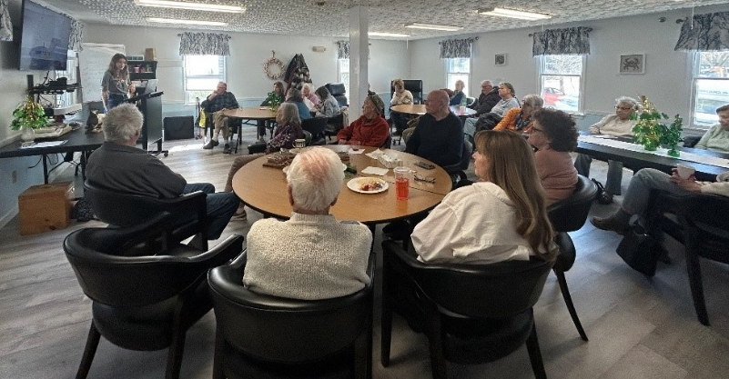
Educators from the Massachusetts Audubon presented at the CFAL on the Winter Birds of Cape Cod. This program was well attended, and the first collaborative program with the Ryder’s Cove Respite Program.

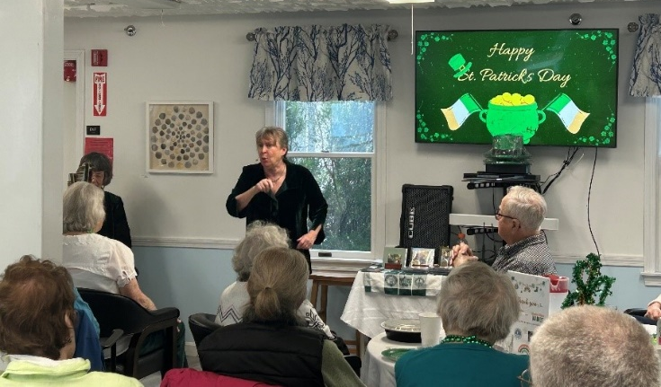
Participants in attendance asked great questions and were given some tips and tricks to identifying the various species of birds.

Entertainment/Socialization
St. Patrick’s Day Luncheon & Legends of Irelands with Diane Edgecomb and Margot Chamberlin
25 participants, 10-person waitlist

The annual Corned Beef and Cabbage luncheon in honor of St Patrick’s Day was extra special this year as it landed on the holiday. Not only did participants enjoy a delicious meal, but a story telling performance of the great legends of Ireland. This program was supported by the Chatham Cultural Council, Massachusetts Cultural Council, and the Friends of Chatham COA. As one of the most popular programs in our calendar year, we had a waiting list of about 10 people due to the limited space available in the current dining room.

Chatham Better Together
20 participants

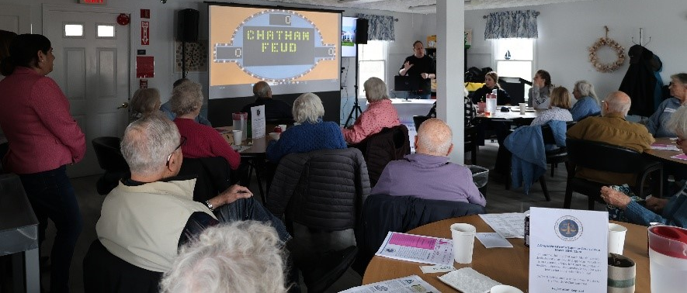
For this month’s gathering the Better Together members enjoyed a live senior game show complete with the witty host, big buzzers, and fun prizes! Participants worked as teams to compete in Family Feud, Wheel of Fortune, and Memory games all geared towards the senior population. Everyone had a blast and requested the host come back again soon.
II.
Services Highlights:

Tech Help
5 participants

This month there were five members of the community who requested a tech help appointment. The following issues were addressed and resolved:
- Setting up and connecting a printer
- Organizing travel documents to be easily accessible electronically
- Updating passwords after a security breach
- Navigating Google Suite
- Virus protection for a personal device

Ryder’s Cove Respite Program:
As the Director of the Adult Supportive Day Program, I am pleased to present a detailed overview of our program’s progress and significant developments for the month of March 2025. The program continues to evolve, and we are excited to share our achievements, improvements, and plans for continued success.

Ryders Cove Respite Support Day Program
During March, the program successfully supported five older adults who are experiencing cognitive decline and memory-related challenges. This month marks an important milestone as we reflect on the initial phase of the program, which began in January. We have made substantial progress in developing systems that ensure smooth communication between caregivers and program staff.
Key Highlights:
- Communication Books: We introduced Communication Books to provide caregivers with essential updates on participants' daily activities. These books cover a wide range of topics including:
  - Exercise sessions
  - Music and art therapy
  - Memory games
  - Nutritional snacks and meals
Additionally, these books offer a space to address any concerns raised by caregivers or staff, ensuring ongoing dialogue and feedback.

Program Preparation and Scheduling
We are continuously working to enhance the program experience by prioritizing activity planning, memory care practices, and fostering overall physical and cognitive well-being.
Notable Program Developments:
- Health & Fitness Activities: Our health and fitness program has expanded with the addition of activities such as ball catching, small weights, and exercise bands. These exercises help maintain coordination, balance, and improve blood circulation, ultimately supporting cognitive function and memory.
- Local Entertainers & Guest Speakers: We have successfully engaged local entertainers to provide enjoyable and stimulating social experiences for our participants. In addition, we’ve secured guest speakers who bring diverse educational content.
- Music Therapy Expansion: To further enrich the program, we’ve hired an additional music entertainer, complementing our two current Music Therapists. These professionals will alternate conducting bi-monthly music therapy sessions. Additionally, we have invested in percussion instruments to further engage participants and enhance their musical experiences.
- Dog Therapy Sessions: Monthly Dog Therapy sessions have been introduced to provide emotional support and comfort to our participants.
- Local Historians: We’ve scheduled several local historians to engage with participants, offering fascinating talks. In March, participants enjoyed a "Planting" session with a local gardener and a presentation on the history of Christmas trees.
- Dementia-Specific Aids: To further promote cognitive engagement, we’ve acquired a range of dementia-specific tools, including puzzles, memory care aids, fine motor skill crafts, art supplies, and other materials that encourage mental stimulation.

Staffing and Recruitment
I am delighted to report that all positions within the day program are now filled with qualified personnel, ensuring that we have the necessary support to provide excellent care and engagement for our participants.

Person-Centered Programming & Goal Development
With the program now in its third month, we continue to focus on person-centered programming tailored to the specific needs and preferences of each participant. Our team works closely with Day Program Aides to develop individualized care objectives and personal care plans, ensuring that participants receive support aligned with their unique goals.
Recent Activities:
- I have completed an initial summary of each participant’s progress, engagement, and evolving needs.
- Personal discussions with caregivers have been held to provide updates and receive feedback on how their loved ones are progressing. These conversations allow us to address any concerns and fine-tune our programming to best serve everyone.

Training & Professional Development
To further my knowledge and understanding of Dementia and cognitive decline, I have registered for a two-day training program scheduled for May 2025. The course will be conducted by Dr. Moss, Ph.D., and Dr. Seiber, Ph.D., focusing on the following topics:
Training Topics Include:
- Understanding Executive Function
- The Impact of Stroke on Cognitive Health
- Aging, Memory, and the Phenomenon of "Superagers"
- Anxiety, Sleep, and Brain Health
- Cognition, Successful Aging, and Nutrition
- Calming an Overactive Brain
- Managing Acute Stress and Fatigue
- Psychobiology of Fatigue
- Full Catastrophe Living
- Listening to the Body
This training will equip me with valuable insights and strategies to further enhance the care and support we provide for our participants.

Conclusion
March 2025 has been a successful month for the Adult Supportive Day Program. We had the privilege of serving five participants, each attending sessions on either Tuesdays, Thursdays, or both days. I am particularly pleased to share that, for the first time since the program began, we came very close to achieving 100% attendance for the month of March.
Looking ahead, we are committed to further expanding the program and providing meaningful, individualized engagement for all participants. We will continue to develop personalized care plans, introduce new activities, and refine our program offerings to best meet the needs of those we serve.
Thank you for your continued support of our program.
Council on Aging Board of Directors:
The Council on Aging Board of Directors met on Monday, March 17th. Due to diminished attendance, the Board discussed setting new goals for the upcoming fiscal year, and the proposed Expansion and Renovation of the Existing CFAL Project.

The Human Services Committee:
There was no meeting of the Human Services Committee in March, 2025. The next meeting will be held on Monday, April 14th.
RECREATION AND BEACHES DIVISION

The Recreation & Beaches Division is committed to enhancing the quality of life for all Chatham Residents, by striving to provide the best recreational programming and park facilities possible.

PARK Program (Positive Afterschool Recreation for Kids)
The PARK Afterschool Program is for students in grades 3-7 to have a safe, fun, and engaging afterschool experience. It is also the intent of the program to foster a sense of community and to forge new and lasting friendships among the students attending the program.
PARK Events March:
Wednesday March 21st- Early release day with Mobile Gaming Truck
Wednesday March 26th- Early release day with inflatable obstacle course

 | December | January | February | March
MONTHLY ATTENDANCE | 481 | 663 | 454 | 618
MONEY COLLECTED | $6,120 | $8,155 | $5,605 | $7,685
AVERAGE DAILY ATTENDANCE | 32 | 31.6 | 37 | 29

Programming
Adults:
Winter Tuesday Night Pickleball-70 participants
Winter Thursday Night Pickleball-70 participants
Winter Saturday Night Pickleball- 66 participants
Winter Pickleball Mon-Friday 8am-12pm – 336 participants
Winter Adult Basketball- 41 participants
Winter Floor Hockey- 28 participants
Winter Pickleball Lessons- 16 participants
Adult Badminton-17 participants
Yoga with Jackie! (Hatha Mondays)- 47 participants
Yoga with Jackie! (Restorative Thursdays)- 50 participants
Yoga with Jackie! (Vinyasa Fridays) – 28 participants
Fly Casting- 15 Participants
Youth
March Family Karte- 13 participants
March Family Tai Chi- 8 participants
Preschool Soccer- 24 participants
Basketball Grades 5-6 Boys- 10 participants (1 team)
Basketball Grades 3-4 Boys- 18 participants (2 teams)
Basketball Grades 1-2 Co-ed – 29 participants
Kindergarten Basketball- 16 participants
March Birthday Parties-0
Parties are available on Saturdays and Sundays with use of the Gym, Game Room, and Teen Room as options.
Special Events
On Friday February 7th we hosted Henry the Juggler through a cultural grant. The event was free for families and included pizza and snacks for participants. Over 50 participants enjoyed the event.
On Friday March 14th, the Municipal Lower Cape Basketball league hosted a Basketball Hot Contest. Multiple members of our teams participated in the 2nd annual event held at Nauset Middle School.
On Sunday March 16th, we sponsored a Family Skate Session at Charles Moore Arena. This event is co-sponsored with Harwich Recreation. 50+ members of the communities enjoyed this free event.
Employee Development/Enrichment/Other

On Thursday March 13th, Sue Frederick (Recreation Coordinator) and Sharon Stark (Recreation Supervisor) attended the Cape Cod Tech job fair. The job fair is held during the students’ lunch period for the entire school.

On Wednesday March 19th, Aimee Howell (Community Services Deputy Director), Sue Frederick (Recreation Coordinator), Nick Delande (Recreation Assistant) and Kaeden Quinn (Recreation Assistant) attended the annual Massachusetts Parks and Recreation Conference in Norwood, MA. At the conference, the team accepted the Community Impact Award for the Cape and Islands Region. The award was given to Chatham Recreation due to our work with the new pickleball courts, friends of pickleball, and our focus on Special events in the last year.

On Wednesday March 26th, Aimee Howell (Community Services Deputy Director) attended the lower cape MRPA sports meeting in Eastham. A wrap up of the lower cape’s basketball league was discussed at the meeting along with the upcoming Lower Cape softball season.

Community Center Use
Aerobics Room - 65 Reservations
Chatham Tai Chi, Circuit Class with Rachel, Heisig Belly Dance, Lite Fitness with Susan Hunter, CFAL Move and Groove, COA Strong at Heart, COA Chair Yoga, Friday Family Karate, Friday Tai Chi, Hatha Yoga, Restorative Yoga, Nordic Walking, Vinyasa Yoga, Mixed yoga Saturday, mahjong.

Arts & Crafts Room – 3 Reservations
Crafty Chicks, Fiber Arts

Club Room – 17 Reservations
AARP Tax Aide, Women’s Club Knitting Group, Friends of Chatham Waterways, Bolus Card Game, Men’s Club weekly discussion group, Monomoy After Prom Committee.

Conference Room – 16 Reservations
Park & Recreation Committee, Men’s Club Programming Committee, Fiber Arts, Republican Town Committee, Garden Club of Chatham Board meeting, Chatham Platform Tennis, Ecumenical Council for the Homeless, Chatham Cemetery Commission, Friends of Trees, Chatham Golf Advisory Committee, Chatham HR/Boston Mutual, Chatham Bikeways Committee, Chatham Independence Day Parade Committee, Chatham Democratic Committee.

Gymnasium – 89 Reservations
Grade 1 & 2 basketball, Fly Casting, Saturday Night Pickleball, Monday pickleball 11-1, Pick up basketball, Tu & Th pickleball 8-10, Tu & Th pickleball 10-12, COA Indoor walking group, Tues. Night pickleball, We & Fr pickleball 8-10 & 10-12, beginner pickleball lessons, Thurs. night pickleball 5-7, winter floor hockey, Henry the Juggler Family Event, advanced pickleball lessons, preschool soccer ages 3-5.

Large Meeting Room – 25 Reservations
US Coast Guard Auxiliary, Chatham Conservation Foundation, COA Wellness Warriors, DPW Holiday Party, Friends and Gardeners, Men’s Club weekly meeting, Community Services meeting, Women’s Club of Chatham, PARK After School, Women’s Club Epicurean Group, Bolus Card game, Chatham Hospital Auxiliary.

Serving Room – 12 Reservations
AARP Tax Aide, Community Mahjong, Chatham Harwich Hospital Auxiliary, Women’s Club knitting group, Friends of Chatham Pickleball, Chatham Women’s Club Board meeting.

Fitness Room Access Scans
 | Sunday | Monday | Tuesday | Wednesday | Thursday | Friday | Saturday | Total
December | 60 | 172 | 113 | 104 | 130 | 103 | 118 | 800
January | 57 | 129 | 141 | 136 | 188 | 151 | 132 | 934
February | 65 | 109 | 149 | 146 | 145 | 115 | 107 | 836
March | 44 | 193 | 135 | 135 | 141 | 97 | 131

Active Fitness Room Memberships: Family Members- 479 Individual Members- 179

Parks & Recreation Commission:

The Parks & Recreation commission met on Monday March 3rd. At the request of the Commission, local businesses that transport passengers over to North Beach Island met to discuss issues and concerns from past summers. Representatives from Chatham Bars Inn and The Beachcomber attended the meeting. Discussion ensued about making sure patrons were aware of the rules and regulations along with the dangers associated with North Beach Island. Chatham Harbormaster Jason Holm was also in attendance. The business representatives and the town agreed to work together to promote safety and rules. The businesses will show patrons a QR code that will take them to our rules and regs and safety issues. They will also have open lines of communication with any concerns they have and relay them to the town.

A final draft of North Beach Island and Parks and Beaches Rules and Regulations were approved by the Commission and recommended to be approved by the selectboard at an upcoming meeting.

New Permission to Use Town Property guidelines, fees, and policies were presented to the Commission. The Commission asked that town staff add more details to some aspects and bring them back to a future meeting to be approved.

An update on the CFAL relocating to the Community Center if the project passes at the town meeting was discussed. The two divisions have been meeting regularly to discuss the logistics so that if the project passes, the project can start right away, and the divisions are ready to implement the plan.

An update on the Community Centers Cleaning Contract was given to the commission. The contract runs through June. It was noted that town staff are aware of the poor services from the current contract holders. The commission was happy to hear that the fitness room and gymnasium will be added to the new contract as they were not included in the current contract.

Golf Advisory Committee

The Golf Advisory Committee met on Thursday March 20th. An update on the Pump House maintenance was discussed. DPW has removed tree branches, small trees, and holes in the siding were repaired. A broken window was replaced along with an adding wire to the outside to stop golf balls from breaking the window in the future. Parks & Grounds will remove brush close to the building and replenish rocks around the foundation of the building as the weather allows.

Susan Mabile gave an update on the current budget and remaining funds for the fiscal year 25.

Jason Laramee of Johnson Golf Management presented 3 different quotes for plantings around the Seaside links sign at the request of the committee. Discussion ensued about different planting options and what the committee wants to ultimately do with the sign and surrounding area. The committee will review the options and discuss at an upcoming meeting.

Jason Laramee also gave the committee an update on the 8th Tee Box rebuild that the committee has been discussing. The committee requested that a quote be brought to the next meeting.

Bruce Bogardus (chairmen) discussed the selectboards goals of ADA compliance around the town. Mr. Bogardus has requested a report on the club house’s compliance and what if anything needs to be done.

Respectfully submitted,

Leah LaCross

Leah LaCross, MPA
Director of Community Services

