COMMUNITY SERVICES DEPARTMENT
DIRECTOR’S REPORT
APRIL, 2025

SUBMITTED TO: Jill Goldsmith, Town Manager
SUBMITTED BY: Leah LaCross, Director of Community Services

FROM THE DIRECTOR OF COMMUNITY SERVICES:

April was another active month for the Department of Community Services. The Recreation and Beaches Division focused on preparations for the upcoming summer season, including the recruitment of seasonal staff. In addition, they began preliminary planning for a potential temporary relocation of the Council on Aging (COA) Division to the Community Center, contingent upon the approval of Article 17 at the Annual Town Meeting (ATM) on May 10th.

At the Center for Active Living (CFAL), the Ryder’s Cove Respite Program (RCRP) concluded its activities under the current grant, with all remaining funds expended and the final report submitted on April 30th, coinciding with the close of the contract.

On April 15th, the Director of Community Services led a training session for the Department and Division Heads, titled “Serving Those with Dementia.” This session provided all Department and Division Heads with practical, research-based communication techniques for effectively engaging residents experiencing cognitive challenges.

The following week, on April 22nd, the Director introduced the proposed Chatham Municipal Academy to Department Heads. Scheduled to launch in the fall of 2025, the Academy will consist of nine sessions, each facilitated by a different department. The final session will include a “Call to Action,” encouraging participants to become actively involved in local government through committee or commission service. Department and Division Heads are currently developing their individual session curricula.

The Employee Engagement and Appreciation Committee convened in April to finalize plans for the upcoming “Grilling and Chilling” staff appreciation barbecue. This event will take place on Thursday, May 22nd, from 11:30 a.m. to 1:30 p.m. at the Community Center and is open to all Team Chatham employees.

Lastly, CFAL hosted its Annual Volunteer Appreciation Luncheon on April 25th. The event featured a “pick-your-own” flower truck and breakfast from Chatham Perk. It was a heartfelt celebration recognizing the valuable contributions of CFAL’s many volunteers, as well as two dedicated interns, Luli and Emily, both seniors at Monomoy High School.

Adult Behavioral Health Clinician:
The month of April had 20 working days in it.
Of the 20 days I worked in April, I had 79 interactions with 21 Chatham residents.
Of the 79 interactions:
41 were Behavioral Health Clinician contacts, which includes in person contact between a CFAL client and myself. It could be at the Center for Active Living (CFAL), Chatham Police Department (CPD), or at their home.
2 were CFAL outreach visits, which include home visits made at the request of outside referrals.
2 were phone outreach calls, which include calls I made to check in on residents, calls with family members, calls with collateral providers, and calls with medical providers.
6 were client consultations, which means I spoke with other providers within and outside of our Town agencies, on behalf of the client.
4 were co-response calls with a Chatham police officer. These are carried out when I need to go to the home of a Chatham resident who is either unfamiliar to me and may be unsafe for me to go alone, or for someone who the CPD is familiar with and insists I go with an officer so that I can safely assess their mental status.
2 were CPD referrals, which include calls that police officers responded to, where the officer feels it necessary for the Clinician to assess the identified client for possible mental health/substance abuse services or referrals.
1 was a CPD well-being referral, which occurred when the officer gives me a “heads up” on a familiar Chatham resident, and I follow up with the client to make sure they don’t need any behavioral health assistance or support.
2 were CPD phone outreach calls, which occurs when a request has been made that I “check in” on a community member who accessed CPD.
2 were CPD referral follow-ups, which means that the identified client is someone CPD has referred to me in the past and I check in on them to make sure they have remained stable.
4 were home visits which are made for those unable to make their way to CFAL or CPD due to physical restraints or transportation issues.
2 were CFAL office visits, which occurred when the resident either had a scheduled appointment with me or agreed to come to CFAL to discuss how I could assist them.
4 were CFAL incoming client calls, which include the number of calls I received from the Chatham residents asking for assistance.
1 was an incoming CPD call, which includes someone calling into CFAL regarding an elder that may be posing a legal threat to the community.
4 were phone contacts which occur when a Chatham resident calls in looking to meet with the clinician to discuss ideas that fall in the realm of behavioral health.
1 was a CFAL follow up outreach contact, which includes following up either with a phone call or home visit, to a resident that is of concern to a CFAL member.
1 was a CFAL referral, which occurs when someone from CFAL requests that I make contact with a CFAL member

Community Connections:
This month, I spent 12 hours participating in a variety of trainings and conversations; some were monthly commitments, and some were new. This month I took part in a discussion with several of our Board of Selectmen, as well as participated in CPR/First Aid Training at Chatham Fire.
I was asked to take part in a discussion with Chief Anderson and several of our Select Board members, to have a dialogue concerning an issue with one of our community residents. It was very productive and gave me the opportunity to see how the Select Board conducts concerning incidents in our Town. Together we had a useful conversation where we all had a voice at the table and came up with a unanimous solution.

I also participated in a First Aid/CPR/Stop the Bleed training at Chatham Fire Department. This was beneficial to me, as we reviewed situations that were actual scenarios that I may encounter in my day-to-day job.
I continue to attend our CCIT (Community Crisis Intervention Team) Meetings in Orleans and Dennis, where I can discuss clients of concern and the other team members share their cases as well.
I also attended a presentation called Lunch and Learn by my CFAL colleague, Kerri Kelly, that showcased the Teams application. Our town of Chatham uses Teams, which allows us the opportunity to communicate amongst departments in a timely fashion. There are so many ways to use the application that cut down on time and paper use.
Last, I attended a viewing of a documentary called “Lift the Mask: Portraits of Life With Mental Illness,” that focused on mental health in our Youth. I met parents and professionals from throughout New England that were present to discuss the importance of supporting our teens and their mental health.
April Reflection
Refusal. That is what I was faced with this past month.
What do you do when a client needs services, but they don’t want to accept them? That is what I met with repeatedly last month. There are very clear rules that are in place when it comes to offering a client assistance- be it housing, mental health, medical, food, or financial. Unless a client is at imminent risk of harm to self or others, it is purely up to the individual if they want to accept services offered.
It can be very difficult to sit with, as you watch someone suffer when there is help out there, but that is what I ran into several times last month. It took a lot of patience, support from my colleagues, and compassion to recognize that the people I work with have a right to refuse help. They are allowed to live the way they want to live, even if I don’t feel comfortable with it. Not to say that there aren’t limits, because there are, but this was the first time that I felt the pain and frustration family members sit with when they must watch their loved ones suffer. It is heartbreaking, and it is real.
Despite the sadness and frustration I face in this position, there are just as many days of job and love and compassion, and that is what keeps me going.

COA DIVISION:
Outreach:
In the month of April, Outreach had a total of 133 interactions, with 80 separate individuals. This month, Outreach saw yet another increase in safety and well-being checks.
Outreach received 5 new consultation referrals from Chatham Police, Fire and EMS services, leading to co-response services. This increase in collaborative services leads to a better understanding of care and resources across all participating departments.
The Outreach Coordinator made 18 home visits for 17 separate individuals. There were 9 well-being checks performed on members referred from CFAL staff and community members concerned about residents.
For April we maintained similar numbers for telephone consultations (71), serving 42 individuals. Outreach had 31 in-person office consultations at CFAL. April saw an increase in community members with concern for our elderly population. General wellbeing and access being the main contributors for the increase. We referred 15 individuals to 7 different Community partners for support this month.
Healthy Meals in Motion served 34 families this month. We continue to see requests for assistance and next month, several families will be returning to the program after a brief hiatus.
On April 17th the LGBTQ+ Older adult group met for dinner. A simple but fun dinner with pizza and ice-cream from Pizza Shark. The group has been working on a plan to increase attendance and add members. After much discussion and a few brief surveys, we decided to hold 2 larger events for the last 5 months of the grant. All were excited and looking forward to the upcoming events.
UPDATE: Unfortunately, we received news from Elder Services of Cape Cod, that due to budget constraints, the grant funding for this program has been halted for the foreseeable future. Outreach will maintain contact, updating the group with news of other activities and events in the area. We will also continue to be available for support and services should the need arise.
The Outreach Coordinator manages durable medical equipment (DME), and this month 15 items were lent to 14 individuals. The inventory has been low on rollators and wheelchairs, our biggest requests. We have had multiple new donations of DME.
On April 8th the Outreach Coordinator gave a 45 min presentation to the local St Vincent DePaul chapter. We discussed all the services we offer as well as the community partners that we refer to. This was a very informative discussion for both sides.
The Outreach Coordinator visited the Anchorage at Chatham Housing Authority, for a “Meet and Greet” coffee hour on April 22nd. We offered an overview of services and programs available at the Center for Active Living, as well as a question-and-answer session that proved to be helpful and informative.
Transportation:
April brought a mix of seasonal changes and a notable increase in transportation usage this month, with 48 more round-trip rides compared to March. Our services supported residents with a range of needs, including:
Orleans Supportive Day Program
- 6 participants
- 46 round trips
Ryders Cove Respite Program
- 5 participants
- 27 round trips
Medical Appointments
- 42 round trips

Grocery Access
- 8 pantry deliveries
- 18 resident trips to Stop & Shop (Thursdays)
- 15 deliveries from The Chatham Village Market
Pharmacy Support
- 6 prescription deliveries

Council on Aging Programs
A total of 27 participants engaged in a variety of COA special programs, including:
- COA Cinema
- Busy Fingers
- Book Club
- Chair Yoga
- Chatham Better Together
- Lunch and Learn
- Bingo

Additional Services Provided
Transportation support also extended to:
- Banking Trips
- Tax Appointments
- Library Visits
- Personal Errands

Scheduling Update
With several participants transitioning out of the Orleans Supportive Day Program, both Supportive Day Transportation Programs will now run on Tuesdays and Thursdays only. This adjustment allows us to expand medical appointment transportation availability to earlier hours (before 10 a.m.) on Mondays and Wednesdays.

Special Outing Highlight
On April 18th, Chatham Better Together organized a successful group outing to the Whydah Museum, followed by lunch at the Dennis Kream 'n Kone. A full bus of 12 participants enjoyed the experience.

Vehicle Maintenance
To ensure the reliability of our transportation services, routine maintenance was completed:
- Our small van received an oil change and a new inspection sticker
- The Ford Transit van also passed its vehicle inspection

Programming:

Summary:
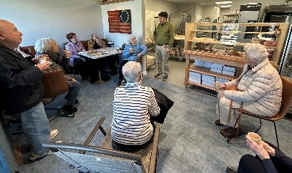
This monthly report outlines the activities and achievements of the Chatham Council on Aging Program Coordinator for the month of April in the year 2025.
Program Highlights:

Community Engagement :
- Liberty Bakery Tour
16 participants
Members of the community were invited to take a tour of Liberty Artisanal Bakery, a new business in town. Along with a full facility tour and taste test of breads and pastries made on site, participants were able to meet the owners, learn about their history, and gain insights into their business operations here in Chatham.

- Chatham Conservation Foundation: Mammals in Chatham
16 participants
Conservation Agent, Elijah Valentine, came to the CFAL this month to share about the mammals they are seeing in Chatham, and how to identify them. Never seen before trail camera footage of coyotes, deer, otters, and more were thoroughly enjoyed by those in attendance.
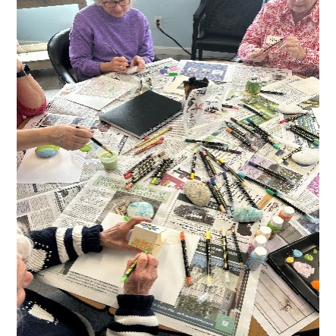
Entertainment/Socialization:
- Rock Painting Workshop
12 participants
6 Ryder’s Cove Respite participants
In honor of Earth Day an art workshop was hosted this month. Volunteers collected and donated rocks for participants to use for this project.

- Chatham Better Together
20 participants
Members of Chatham Better Together visited the Whydah Pirate Museum in Yarmouth this month, followed by a lunch at Kream & Kone. Many among the group had not had an opportunity to visit the museum yet so the guided tour was an excellent learning experience.
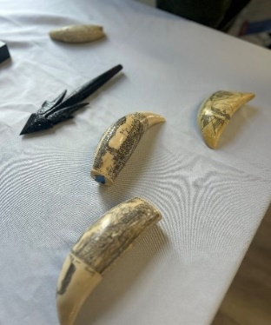
Education/Information:
- Life Aboard a Whaleship
25 participants
The Nantucket Historical Association visited Chatham this month to share the “On the Road Overseas” program, Life Aboard a Whaleship. NHA On the Road brings Nantucket’s rich history and stories to senior residents’ island wide and beyond. This presentation took a deep dive into the whaling industry during the 1800s on Nantucket, including footage from a 1920s whaling trip, authentic whale bone scrimshaw and stories from whalers’ journals.
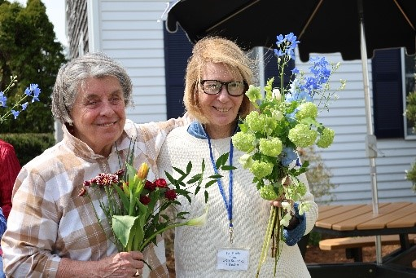
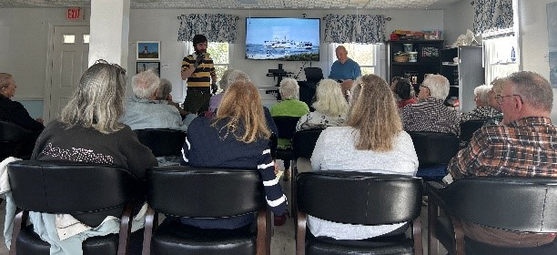

Volunteer Program:
- Appreciation Event
30 participants
In honor of Volunteer Recognition Week, we had an appreciation event for our volunteers to celebrate the incredible contributions of our 35 dedicated volunteers. Collectively, our volunteers have given over 1000 hours this fiscal year. The event featured a visit from a local flower truck, where volunteers created their own custom bouquets, followed by a delicious brunch spread from Cape Cod Coffee- Chatham Perk. During a brief recognition ceremony, we honored our top three volunteers: a SHINE counselor with 200 hours, a member of the Friends board with 175 hours, and COA Board member with 150 hours. It was a heartfelt and joyful occasion to show our gratitude for the time, energy, and compassion our volunteers bring to our community.

Ryder’s Cove Respite Program:
As the Director of the Adult Supportive Day Program, I am pleased to present an overview of the program’s progress and key developments for the month of April 2025.
Overview
April was a meaningful and fulfilling month at Ryders Cove. We had the privilege of supporting five older adults living with cognitive decline and memory-related challenges. Our team remains committed to creating a nurturing environment that emphasizes dignity, respect, and personalized care. We continue to make progress in strengthening communication between caregivers and staff to ensure our participants feel supported both at home and during their time with us.
Key Highlights
Communication Books
To help caregivers stay connected and informed, we introduced personalized communication books. These provide daily updates on each participant’s activities and well-being, covering areas such as:
- Gentle exercise sessions
- Music and art therapy
- Memory games and activities
- Nutritious meals and snacks
These books also serve as a valuable space for open dialogue—where caregivers and staff can share insights, observations, and concerns. This ongoing exchange helps us adapt and respond with empathy and care.
Program Preparation and Enrichment
Our focus continues to be on designing meaningful, engaging experiences that support participants’ physical health, cognitive abilities, and emotional well-being.
Program Highlights:
- Health & Fitness: We’ve expanded our movement offerings to include ball games, light weights, and resistance bands. The exercise program is incorporated into our daily schedule. These activities support coordination, balance, and circulation—all essential for cognitive and physical health.
- Rock painting. The day program participants were invited to share in a rock painting class this month and it was a success.
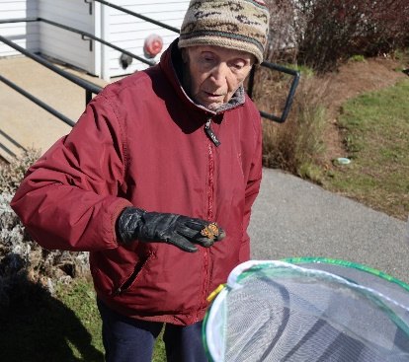
- Earth Day Celebration: In honor of Earth Day, we introduced four butterfly garden habitats. Participants enjoyed the hands-on experience of observing caterpillars transformed into butterflies and were thrilled to release 37 into the wild.
- Engaging Guests: Local entertainers and guest speakers have brought joy, laughter, and learning into our space. These visits not only entertain but help build a sense of connection and community.
- Music Therapy Expansion: We've welcomed an additional music entertainer, joining our two Music Therapists in offering twice-monthly sessions. Our recent investment in percussion instruments allows for more hands-on, expressive engagement.
- Therapy Dogs: Monthly dog therapy visits continue to bring smiles, comfort, and emotional support—often becoming a highlight of the week for our participants.
- Dementia-Specific Tools: To support mental stimulation, we’ve added a thoughtful selection of memory aids, puzzles, fine-motor crafts, and art materials, tailored to participants’ needs and abilities.
Staffing
We are proud to report that our team is fully staffed with dedicated, compassionate professionals. With this strong foundation, we’re able to provide high-quality, person-centered care across a wide range of services, including:
- Memory care support
- Therapeutic programming
- Art therapy
- Music therapy
Each team member brings warmth, skill, and a deep sense of purpose to their work.
Person-Centered Programming & Individual Goals
Now in its fourth month, the program continues to evolve based on the unique rhythms, preferences, and needs of each participant. While we’ve developed a structured daily schedule rooted in best practices, we’ve learned that flexibility and responsiveness are key. Some days call for quieter engagement, others, for more active participation. Our team adjusts with care and attentiveness to ensure every individual feels seen, heard, and respected.
- Initial progress summaries for each participant have been completed, providing insights into engagement levels, strengths, and emerging needs. A follow-up report will be prepared in June.
- Ongoing, compassionate conversations with caregivers have allowed us to share updates and receive meaningful feedback, helping us fine-tune each care plan.
Training & Professional Growth
To deepen my knowledge and enhance the support we offer; I’ve enrolled in a two-day professional development course in May 2025. Led by Dr. Moss and Dr. Seiber, the training will cover important topics such as:
- Executive function and aging
- The cognitive impact of stroke
- The science of memory and “Super Agers”
- Sleep, anxiety, and brain health
- Strategies for managing stress and fatigue
- Listening to the body and supporting holistic wellness
These insights will further strengthen our team’s ability to provide compassionate, informed care for those we serve.
Attendance Percentage: 93.75%
We’ve seen exciting progress this month, particularly with one participant who was initially quiet and hesitant to engage. Over the past few weeks, she has begun participating in music therapy and group activities, smiling, laughing, and forming meaningful social connections. Watching her come out of her shell has been a reminder of the power of a safe and caring environment.
We remain committed to offering personalized, joyful, and therapeutic experiences. As we continue to grow, we do so with appreciation—for the trust caregivers place in us, and for the privilege of supporting each participant on their journey.
Conclusion
April was an encouraging month at Ryders Cove. Attendance remained steady, and participants are becoming increasingly comfortable, engaged, and connected with our staff and one another.
Council on Aging Board of Directors:
At the April Chatham Council on Aging Board of Directors meeting, members convened to discuss the election of new officers, warrant articles pertaining to the COA to be voted on at the upcoming Annual Town Meeting, and the goals and objectives of the board for FY 26. Additionally, the Board was invited to attend the Annual Meeting of the Friends of Chatham Council on Aging.
A vote for new officers will take place at the May 19th meeting. The Board reviewed proposed articles scheduled for the Annual Town Meeting. Discussion focused on the potential impact on current operations, community feedback on the proposal, and ways the board can be supportive to CFAL staff if any transition is to occur. The final portion of the meeting was dedicated to discussing strategic goals and objectives for the year. Members agreed to revisit and refine these goals at the May meeting following the Annual Town Meeting.
The Human Services Committee:
The Human Services Committee met on Monday, April 14th, where Chair Ann Wade announced that after Select Board Approval, the Committee was formally reduced from 9 to 7 members.

RECREATION AND BEACHES DIVISION

The Recreation & Beaches Division is committed to enhancing the quality of life for all Chatham Residents, by striving to provide the best recreational programming and park facilities possible.
PARK Program (Positive Afterschool Recreation for Kids)
The PARK Afterschool Program is for students in grades 3-7 to have a safe, fun, and engaging afterschool experience. It is also the intent of the program to foster a sense of community and to forge new and lasting friendships among the students attending the program.
PARK Events April:

 | January | February | March | April
MONTHLY ATTENDANCE | 663 | 454 | 618 | 489
MONEY COLLECTED | $8,155 | $5,605 | $7,685 | $6,180
AVERAGE DAILY ATTENDANCE | 31.6 | 37 | 29 | 29

Programming
Adults:
Spring Tuesday Night Pickleball- 65 participants
Spring Thursday Night Pickleball-65 participants
Spring Saturday Night Pickleball- 53 participants
Spring Pickleball Mon-Friday 8am-12pm – 309 participants
Spring Adult Basketball- 37 participants
Spring Floor Hockey- 23 participants
Spring Pickleball Lessons- 6 participants
Spring Adult Badminton-6 participants
Yoga with Jackie! (Hatha Mondays)- 19 participants
Yoga with Jackie! (Restorative Thursdays)- 9 participants
Yoga with Jackie! (Vinyasa Tuesdays) – 29 participants
Youth
April Family Karte-7 participants
April Family Tai Chi- 7 participants
Preschool Soccer- 24 participants
April Vacation Field Trip Heritage Adventure Park- 32 Participants
April Vacation Field Trip NOVA Trampoline Park- 37 Participants
April Vacation Field Trip Urban Air- 38 participants
March Birthday Parties-1
Parties are available on Saturdays and Sundays with use of the gym, game room, and teen room as options.
Special Events
On Friday April 11th, Monomoy High School held their annual after-prom party. The event runs from 9pm-5am overnight for all participants of the prom to enjoy a safe night.
On Friday April 18, we hosted a Jellybean BINGO Jamboree. With prizes for all who attended along with popcorn and drinks, the event was another great success. 37 participants enjoyed the event.
Summer Rec Program

April was a busy month for our seasonal staffing search. The Summer Rec Program filled all positions needed with 21 staff hired/rehired for this upcoming summer season.
Beaches
Recruiting lifeguards continues to be a struggle cape wide including Chatham. We have currently hired/rehired 18 guards for the upcoming season. Beaches open June 20th .
We currently have filled all our Beach Gate Attendant positions with 7 re-hires/hires.
Non-Resident daily tickets along with weekly and seasonal passes have all been ordered. Purchasing non-resident tickets/passes will open on June 1st.
Community Center Use
Aerobics Room – 71 Reservations
Circuit Class with Rachel, COA Chair Yoga, Restorative Yoga, Lite fitness with Susan, Friday Night Karate, Friday Family Tai Chi, Heisig belly dance, Chatham Tai Chi, Vinyasa Yoga, Classic Hatha Yoga, COA Strong at Heart.
Arts & Crafts Room – 3 Reservations
Crafty Chicks, Chatham/Harwich Fiber Arts Club
Club Room – 24 Reservations
Men’s Club weekly discussion group, Bolus weekly card games, Behavioral Health Innovators, Woman’s Club Board meeting, Women’s Club knitting group, Chatham/Harwich Fiber Arts, AARP Tax Aide, Monomoy Regional After Prom, Friends of Chatham Waterways, IT Hybrid set up, Chatham Chamber of Commerce, Chatham Democratic Committee.
Conference Room – 16 Reservations
Men’s Club Program Committee, Women’s Club knitting group, Chatham Parks & Recreation Commission, Chatham Garden Club Board meeting, Chatham Fiber Arts, Men’s Club Executive Committee, Chatham Ecumenical Committee for the Homeless, Monomoy Regional After Prom, Independence Day Parade Committee, Art Journaling Group, Chatham Cemetery Committee, South Chatham Public Library Board, Chatham Bikeways Committee, Portside Village Condo Assoc.
Gymnasium – 89 Reservations
Saturday Night Pickleball, Monday pickleball 11-1, Spring pick-up basketball, Tu & Th pickleball 8-10, Tu & Th pickleball 10-12, COA Indoor walking group, Tues. Night pickleball, We & Fr pickleball 8-10 & 10-12, Thurs. night pickleball 5-7, pick-up badminton, Spring floor hockey, open gym, Monomoy After Prom Party, Saturday Movers & Shakers, pre-school soccer ages 3-5.
Large Meeting Room – 26 Reservations
Chatham Democratic Committee, Friends & Gardeners movie day, Chatham Men’s Club weekly meeting, Chatham Police Assoc. kids easter party, Chatham Police Department Citizens Police Academy Graduation, Broad Reach Hospice, CMEA meeting, Women’s Club of Chatham , Monomoy Regional After Prom Party, US Coast Guard Auxiliary Navigation Presentation, Chatham Republican Town Committee, Chatham Garden Club, Jelly Bean Bingo, Chatham/Harwich Chapter Cape Cod Hospital Auxiliary, Chatham Conservation Foundation water quality presentation, Chatham CFAL, Monomoy Regional School District.
Serving Room – 13 Reservations
Community Mahjong, Women’s Club of Chatham Board, Friends of Chatham Pickleball, Mahjong Mondays, Women’s Club of Chatham Book Club, Chatham/Harwich Cape Cod Hospital Auxiliary Branch
Fitness Room Access Scans
 | Sunday | Monday | Tuesday | Wednesday | Thursday | Friday | Saturday | Total
January | 57 | 129 | 141 | 136 | 188 | 151 | 132 | 934
February | 65 | 109 | 149 | 146 | 145 | 115 | 107 | 836
March | 44 | 193 | 135 | 135 | 141 | 97 | 131 | 876
April | 37 | 113 | 168 | 105 | 122 | 99 | 134 | 778

Active Fitness Room Memberships: Family Members- 491 Individual Members- 184

Parks & Recreation Commission

The Parks and Recreation Commission met on Monday April 7th. The meeting started off with requests to use town property.

Lighthouse Beach Yoga/Jennifer Norton requested the use of Lighthouse Beach for her summer yoga classes. The recreation commission unanimously recommended approval of the request based off the proposed updated Permission to Use rules and regulations. Witches on the Water requested use of Oyster Pond for their annual charity event in October. The Commission unanimously recommended approval of the request based off the proposed updated Permission to Use rules and regulations. Short N Sweet Ice cream requested use of Volunteer Park bike path entry for a charity fun run 5k on June 14th. The recreation commission unanimously recommended approval of the request based off the proposed updated Permission to Use rules and regulations.

The commission then re-opened discussions from the previous meeting on the proposed updated Permission to Use rules and regulations. Changes that the commission requested in the previous meeting were reviewed. The recreation commission unanimously recommended approval of the proposed updated Permission to Use rules and regulations.

The Commission was given an update on summer staffing for the Recreation and Beaches Division. Our summer rec program is fully staffed, along with our beach gate attendants. As is the previous year’s trends, lifeguards continue to be a struggle to staff. Lighthouse Beach Patrol is also very limited in staff. The commission requested that more work be put into recruiting lighthouse beach staff.

The Commission was given an update regarding the work at Oyster Pond. In conjunction with DPW and conservation division, the project included removal of invasive species, movement of beach grass, and replenishment of Sand. It also included moving 2 benches that were buried under sand.

The Commission was updated on the new porta john contract and the new company Wasted that won the town contract for porta johns this year.

Discussion resumed from a previous meeting regarding North Beach Island. A flyer that will be given to businesses that drop patrons off at the island was discussed and edited. A final draft will be brought to the next meeting for approval.

Golf Advisory Committee

The Golf Advisory Committee did not meet in April.

Respectfully submitted,

Leah LaCross

Leah LaCross, MPA
Director of Community Services

