COMMUNITY SERVICES DEPARTMENT
DIRECTOR’S REPORT
MAY, 2025

SUBMITTED TO: Jill Goldsmith, Town Manager
SUBMITTED BY: Leah LaCross, Director of Community Services

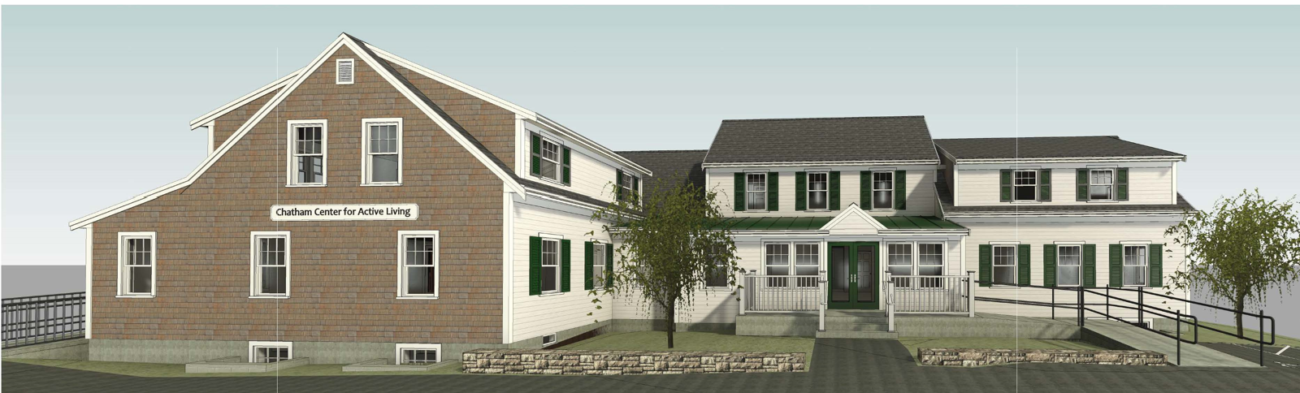
FROM THE DIRECTOR OF COMMUNITY SERVICES:

The month of May proved to be an exciting one for the Department of Community Services. On Saturday, May 10th, Chatham residents voted in favor of renovating and expanding the current Center for Active Living (CFAL) on Stony Hill Road to make it a more efficient and useful space for the 1,487 older adults that are members.

Along with this wonderful development comes a lot of work for both divisions of the Community Services Department. In late August, the staff of the Center for Active Living (CFAL) will be temporarily relocating to Community Center. Madeline “Maddie” Ittner, our Department Assistant, will still greet Center for Active Living (CFAL) participants in the lobby, and our Ryder’s Cove Respite program will now temporarily be located on the second floor “Club Room” on Tuesdays and Thursdays. The administrative staff will be located outside of the building in a temporary office trailer, outfitted with Wi-Fi and network connections. While it will be a tight fit, the staff of both divisions are looking forward to temporarily working under the same roof and getting to know each other much better!

I had the pleasure of attending a two-day intensive seminar on “Advances in Understanding the Human Brain and Dementia” hosted by the National Brain Institute on May 8th and 9th in Hyannis. This deep dive into how the brain functions from birth to advanced age, and how Dementia affects it was an incredible learning experience and has advanced my understanding of the clients served through the CFAL’s Day Program.

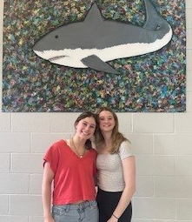
On Friday May 16th, I was invited to Monomoy Regional High School, where the two Senior Class members who served as interns at the CFAL for the school year, presented the summary of all that they learned by providing volunteer service to the Department of Community Services. Luli Hollenbaugh and Emily Brophy (under the supervision of Anna Milan, Program and Communication Coordinator), did everything from setting up programs, running Bingo, answering telephones, organizing files and volunteering with our older adults in the Day Program. Both young ladies will be sorely missed, and we wish them the best of luck as they both enter their freshman year of college.

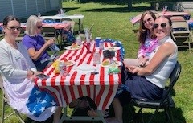
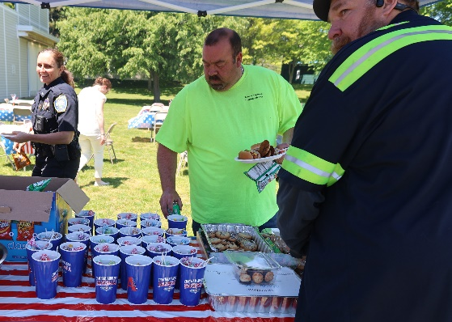
The Employee Engagement and Appreciation Committee hosted its’ First Annual “Chillin’ and Grillin’ cookout at the Community Center on Tuesday, May 27th from 11:30 a.m.-1:30 p.m. This cookout was a way to provide “thanks” to all of the dedicated members of Team Chatham, and approximately 100 people showed up on their lunch break to enjoy hamburgers, hot dogs, various sides, and homemade desserts. Sue Frederick and Aimee Howell manned the grill, and a great time was had by all!

Adult Behavioral Health Clinician:

May Numbers:
The month of May had 21 working days in it.
Of the 21 days I worked in May, I had 83 interactions with 16 Chatham residents.
Of the 83 interactions:
46 were Behavioral Health Clinician contacts, which includes in person contact between a CFAL client and me. It could be at CFAL, Chatham Police Department (CPD), or at their home.
1 was a CFAL outreach visit, which included a home visit made at the request of an outside referral.
4 were phone outreach calls, which include calls I made to check in on residents, calls with family members, calls with collateral providers, and calls with medical providers.
2 were client consultations, which means I spoke with other providers within and outside of our Town agencies, on behalf of the client.
1 was a CPD Referral, which included a call that police officers responded to, where the officer feels it necessary for the behavioral health clinician to assess the identified client for possible mental health/substance abuse services or referrals.
2 were CPD phone outreach calls, which occurs when a request has been made that I “check in” on a community member who accessed CPD.
2 were CPD referral follow-ups, which means that the identified client is someone CPD has referred to me in the past and I check in on them to make sure they have remained stable.
1 was a home visit, which are made for those unable to make their way to CFAL or CPD due to physical restraints or transportation issues.
2 were CFAL office visits, which occurred when the resident either had a scheduled appointment with me or agreed to come to CFAL to discuss how I could assist them.
6 were CFAL incoming client calls, which include the number of calls I received from Chatham residents asking for assistance.
9 were phone contacts which occur when a Chatham resident calls in looking to meet with the clinician to discuss ideas that fall in the realm of behavioral health.
2 were CFAL referrals, which occurred when someone from CFAL requested that I contact a CFAL member
3 were CPD f/u contacts, which means that I either followed up in person or on the phone to a client that the police department felt needed contact with the clinician
2 were phone consultations, which included me contacting outside providers who are also working with my client or who are a resource that my client could benefit from working with.
Community Connections:
This month, I spent 9 hours participating in a variety of lectures, meetings, and our Annual Town Meeting. The month of May marked Chatham’s Annual Town Meeting, where I was pleased to watch the Renovation for CFAL get enough votes to move forward with renovating the existing building.
Next, I attended the monthly CCIT (Community Crisis Intervention Team) Meeting in Orleans, where I feel like the group is now starting to gel and work well together, sharing information that helps each town feel supported by one another.
I also attended a Dementia Training that was sponsored by McLean Hospital. As our elderly population continues to grow in Chatham, and many of my clients suffer from dementia, this presentation was quite helpful and informative.
May Reflection
When “no” really means “yes, please”
What do you do when you encounter an individual who could benefit from outside services (SNAP, Healthy Meals in Motion, Homeless Prevention Council, Dept of Public Health), but declines the help? Do you walk away and hope they call you, OR do you keep coming back to them to check in on them----showing them that you are there for them if they change their mind, with the hope that at some point they will finally accept your offer?
During the month of May, I was met with a bit of resistance from several Chatham residents who needed someone to step in and help them get the resources they needed to start thriving again. These are people who have lived in Chatham for years, yet until they came on the radar of our police officers, no one had ever met them at CPD or CFAL. How can that be? It is likely because of shame or embarrassment or being unaware that services were available to them.
What I have discovered in the short time in my position is that many people in Chatham stay in their homes alone and isolated and are simply surviving. Because of their limited interaction with others in their community, there was a lot of fear and distrust for me. I was a stranger who was asking questions and entering their safe spaces. Why would they trust me? Why would they open up to me? Why would they think I could possibly help them when they have been living without for years and years?
This is the thing with the position of Adult Behavioral Health Clinician, there are so many Chatham residents of ALL ages who could benefit from a helping hand, but there is often resistance. It is my job not to give up on them and to make myself available to them until they are ready to receive help. Some are eager for assistance while some take longer, and then there are those who never take the help. And that is ok.
But my takeaway this month is that I need to be patient with those who initially don’t want any assistance. Behind their eyes is fear--- fear of judgement, fear of getting in trouble with the Town, fear of leaving their homes. But on the other end of this is relief. Relief that they can get help, feel better, and trust someone in the community who is on their side.
It is very gratifying to see clients finally accept help. They start looking better and feeling better and leaving their homes and engaging with their community. As I always say, there is much more work to be done to identify those in our town who are in need of services—and I hope to be here to help them.
Gratitude for my job, my colleagues, our wonderful police officers and fire fighters, and most importantly, our Chatham residents and visitors that I have worked with this year.
My position has created a space for people to feel safe enough to get the services they need, instead of living in the dark and either feeling too embarrassed to ask for help, or just simply not knowing services were available to help them.
Although my job is a work in progress, I feel confident that I can work with my network of colleagues to help our people get the assistance and support they need.

COA DIVISION:
Outreach:
For the month of May, Outreach had a total of 145 interactions, with 67 separate individuals. The most prevalent request this month was for assistance with family members caring for loved ones.
Outreach continues to see an increase in referrals from Chatham Police, Fire and EMS services, leading 11 consultations for 6 individuals. We also saw 2 new referrals from other Town employees leading to follow-up services. We are both pleased and grateful that the community at large feels confident reaching out to help those in need.
Outreach made 17 home visits for 16 distinct individuals. We had 3 well checks on members referred from CFAL staff and community members concerned about participants. There were also 16 continued follow-up consultations on 11 individuals, from previous months.
May saw a slight increase in phone consultations, 74, serving 39 individuals. Outreach had 42 in-person office consultations at CFAL. General wellbeing and access, being the main contributors for the increase. We referred 18 individuals to 8 different Community partners for support this month.
Healthy Meals in Motion served 41 families this month. With 2 new families this month and 3 on-boarding for next month. To gain better insight into the impact this program has on Chatham’s community we are attaching the grid below.
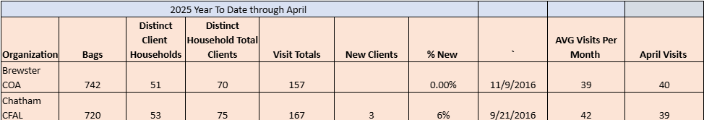
Outreach manages the CFAL’s Durable Medical Equipment (DME) Program, and this month 12 items were lent to 11 individuals. The inventory has been low on rollators and wheelchairs, our biggest requests. Outreach has been restructuring and organizing our inventory in preparation for storage and moving in the fall.
On May 13 Outreach attended Barnstable County’s “Healthy Aging Cape Cod- Reframe Aging” training. This is an initiative to reframe how we think, how we look at and how we act to those in our aging population. Challenging stigmas about the aging process, how to improve access and reducing barriers.
May 15, we attended the MCOA McLean training on recognizing the symptoms of distress in those with declining cognition. Specific signs and symptoms, how to redirect and when. This workshop also focused on the needs of the family caregivers, their burnout and stressors. The real impact caring for a loved one has on the caregiver’s health.
Transportation:

Although May brought its fair share of spring showers, it didn’t slow down our Transportation services. While the month may have felt slightly quieter, our team remained active, ensuring participants stayed engaged and supported as they prepared for the summer season. Throughout May, Chatham residents utilized transportation for the following purposes:
Orleans Supportive Day Program
- 5 participants
- 35 round trips
Ryders Cove Respite Program
- 4 participants
- 18 round trips
Medical Appointments
- 51 round trips
Grocery Access
- 8 food pantry deliveries
- 20 resident trips to Stop & Shop (Thursdays)
- 15 deliveries from The Chatham Village Market
Pharmacy Support
- 6 prescription deliveries
Council on Aging (COA) Program Participation
A total of 23 participants received transportation to a variety of COA programs, including:
- COA Cinema
- Busy Fingers
- Book Club
- Chair Yoga
- Chatham Better Together
- Lunch and Learn
- Bingo
Additional Transportation Services Provided
Thanks to a month with slightly less demand, we were able to accommodate more personal transportation requests, including trips to:
- Banking
- Town Meeting
- Chatham Village Market
- Shoe Repair
- Church
- Library
- Personal errands
- Ocean State Job Lot

While we strive to accommodate these requests whenever possible, medical appointments remain our top priority. In the event of a scheduling conflict, personal trips may be rescheduled to ensure timely access to essential medical care.

Program Highlights & Updates
We’ve also begun to see many of our seasonal residents return. Several have reached out with questions about grocery shopping and prescription delivery services while their family members are away. There has also been increased interest in joining our Thursday grocery shopping trips, which help promote independence by allowing older adults to shop for themselves.
In late May, we welcomed seven (7) new participants, all of whom plan to continue using Transportation services into June. Notably, four of these individuals use wheelchairs and have expressed sincere appreciation for the accessibility features of our vehicles, including ramps and lifts. The availability of these accommodations ensures that mobility limitations do not restrict their access to essential services and community engagement.
Looking ahead to June, we are excited to partner with the Chatham Farmers Market to offer transportation twice a month. Participants will be dropped off approximately 45 minutes prior to opening, giving them time to walk around, browse, and enjoy the market. Once the bell rings, they will be able to shop at their leisure with additional time to continue exploring. We’re proud to collaborate with the market to create meaningful opportunities for older adults to stay active and involved in the community.
Programming:

Summary:
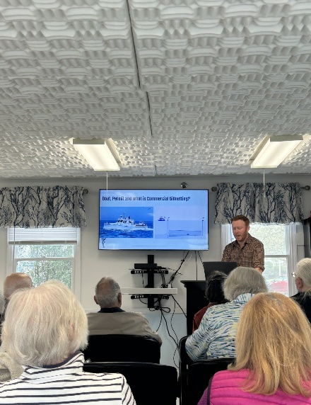
This monthly report outlines the activities and achievements of the Chatham Council on Aging Program Coordinator for the month of May in the year 2025.

I. Program Highlights:
Captain Sean Connors presenting about F/V Dawn Treader.
Community Engagement
- Seafaring Stories
  - 18 participants
  - Third generation Cape Codder, Captain Sean Connors, member of the Chatham Fleet, spoke about his first year of ownership/captaining the F/V Dawn Treader. Participants learned about his fishing background, as well as current industry standards and procedures.
- Community Hero Project Coffee Hour
  - 12 participants
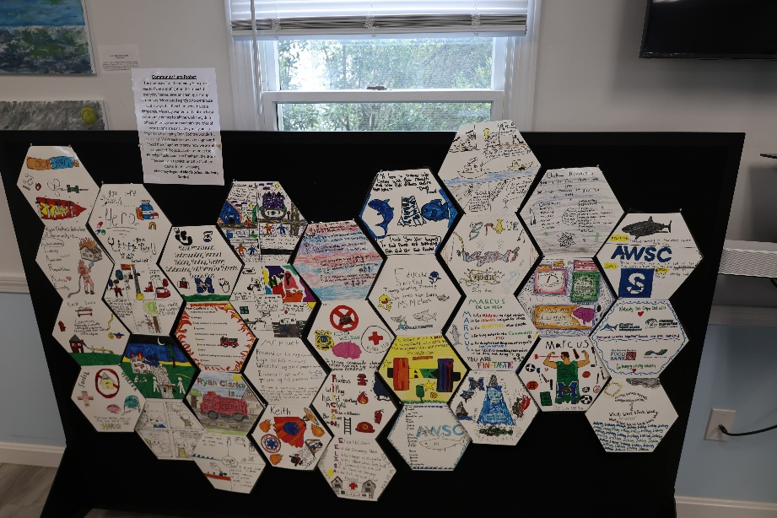
  - During the month of May, the Monomoy Middle School Community Hero Project was displayed at the CFAL for patrons to enjoy. After reading The Finest Hour, 6th graders conducted interviews with Community Heros and wrote about those interviews. Participants were invited to a coffee hour to hear from the middle schoolers about the project process and final products.
Community Hero Final Project displayed at the CFAL.

Entertainment/Socialization
- Chatham Better Together
  - 23 participants
  - Members of the Better Together group were greeted with donuts and coffee at the Water Treatment Facility on Morton Rd before embarking on a behind the scenes tour. The participants were split into groups of 5 to take a guided tour, ask staff questions, and learn about where their water comes from and how it is treated for safe use/consumption. Participants were incredibly engaged and interested in learning about this process and enjoyed a catered meal from Drifters at the CFAL following the tour.
Education/Information
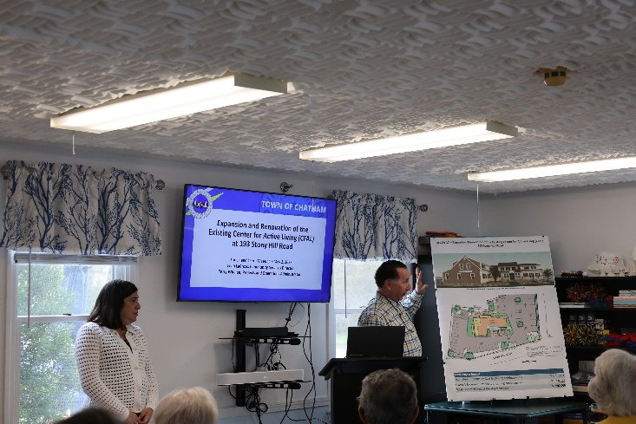
- Lunch & Learn: Renovation and Expansion of the CFAL
L. LaCross and T. Whalen presenting at the CFAL.
  - 29 participants
  - Article 17 at the Annual Town Meeting was the subject of this month’s Lunch and Learn. Community members voted on expanding and renovating the current Center for Active Living to better meet the needs of the community. Special Projects Manager, Terry Whalen, and Director of Community Services, Leah LaCross, took a deep dive into how the project has developed to become Article 17 being voted on by Townspeople. In addition to hearing from Whalen and LaCross, participants had an opportunity to look at site plans up close and ask questions.
- Public Safety Seminar
  - 20 participants
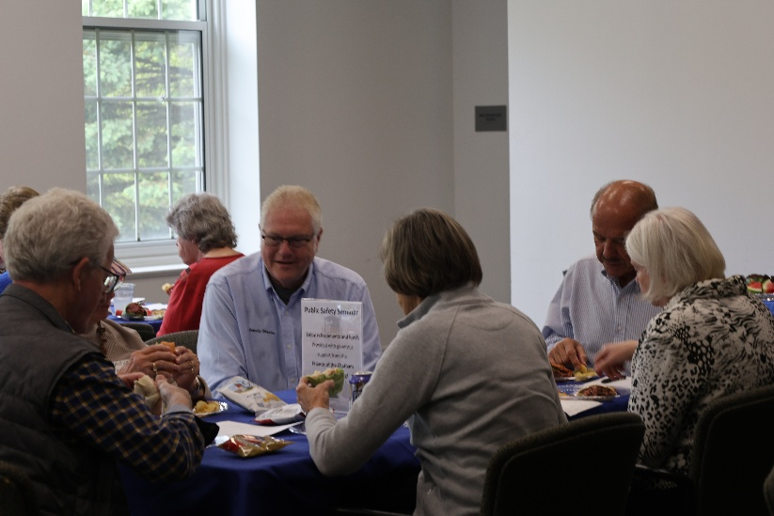
  - A new program offered this month, the Public Safety Seminar, was a 5-hour workshop featuring presentations from Chatham Fire/Emergency Department, Chatham Police Department, and the Council on Aging. Participants learned CPR/AED, Stop the Bleed, Emergency Preparedness, Fire Safety, Fall Prevention, Situation Awareness and Scam/Fraud Prevention. The presentations were broken up with lunch, provided by the Friends of Chatham COA where participants were able to sit with our first responders presenting and ask questions.
Mark Heller, Deputy Director of Emergency Management with participants at lunch.

Ryder’s Cove Respite Program:
As Director of the Adult Supportive Day Program, I am pleased to share this summary of our key developments and progress for May 2025.
Program Overview
May was a meaningful month at Ryder’s Cove. We supported five older adults living with cognitive decline and memory-related challenges. Sadly, one participant transitioned to a long-term nursing facility to receive the advanced care he now requires.
Our team remains deeply committed to providing a nurturing, respectful, and dignified environment—while also offering vital respite to caregivers. We continue to prioritize open, consistent communication between caregivers and staff to ensure seamless support both at home and within the program.
Key Highlights
Communication Books
Individualized communication books continue to keep caregivers informed and involved. These books provide daily updates on participants’ activities and well-being, including:
- Gentle exercise sessions
- Music and art therapy
- Memory games and cognitive activities
- Nutritious meals and snacks
They also serve as a tool for two-way communication, allowing caregivers and staff to exchange insights, observations, and concerns. This ongoing dialogue strengthens collaboration and supports truly person-centered care.

Program Preparation and Enrichment

We remain focused on delivering enriching, therapeutic experiences that promote physical health, cognitive stimulation, and emotional well-being. Notable developments in May include:
- Health & Fitness:
We have expanded our physical activity offerings to include ball games, light weights, and resistance bands. These activities are now part of our daily schedule and are designed to support coordination, balance, circulation, and cognitive engagement. Participants have responded positively to the fitness program, especially enjoying the ball games, which involve catching, throwing, and kicking the ball to one another. These sessions are filled with laughter and fun, while also helping to improve coordination, stamina, balance, and overall physical health.
- Guest Engagement: Local entertainers and guest speakers brought joy and variety to our days, enhancing social connection and mental stimulation.
- Music Therapy Expansion: We now host three Music Therapists, each offering monthly sessions. Recent investment in percussion instruments has increased interactive participation and expressive engagement.
- Therapy Dogs: Monthly visits from therapy dogs remain a highlight, providing emotional support, comfort, and companionship.
- Dementia-Specific Tools: We continue to implement and present new memory aids, fine motor crafts, puzzles, and art materials—carefully tailored to each participant’s cognitive profile and abilities.

Staffing
Our program remains fully staffed with a dedicated team of compassionate professionals. This strong foundation enables us to deliver consistent, person-centered care across the following areas:
- Memory support
- Therapeutic programming
- Art and music therapy
- Social engagement
Each team member brings not only skill and experience, but a deep sense of empathy and purpose to their work.
Person-Centered Programming & Individual Goals

Now in its fifth month, the program continues to evolve in response to the unique preferences, needs, and rhythms of each participant. While we follow a structured daily schedule based on best practices, we remain flexible and responsive—balancing active engagement with moments of rest and quiet.
- Initial progress summaries for each participant have been completed, offering insight into engagement levels, strengths, and emerging needs. Follow-up reports are in progress for June.
- Ongoing, compassionate communication with caregivers allows us to share updates, gather feedback, and continually refine care plans.

Training & Professional Development
In May, I participated in a two-day professional development seminar led by Dr. Moss and Dr. Seiber. Topics included:
- Executive function and aging
- Cognitive impacts of stroke
- The neuroscience of memory and “Superagers”
- Sleep, anxiety, and brain health
- Managing stress and fatigue
- Holistic approaches to wellness
These sessions deepened my understanding of cognitive decline and brain health. I have shared key takeaways and educational materials with staff to further enhance our collective capacity for informed, compassionate care.

Conclusion
Although attendance declined slightly in May—due to one participant’s transition to long-term care and another experiencing health challenges—we maintained a strong attendance rate of 82.5%. Encouragingly, interest in the program continues to grow. Three new applications have been distributed, and one individual has already completed a trial day.
As we look ahead, we remain committed to offering personalized, therapeutic, and joyful experiences. We are deeply grateful for the trust caregivers place in us and for the opportunity to support each participant’s unique journey.

Council on Aging Board of Directors:

The Council on Aging Board of Directors did not meet in the month of May. They will resume meeting in June.

The Human Services Committee:

The Human Services Committee met on Tuesday, May 13th. Patti Gibson reported the following nominations for Officers:
Ann Wade, Chair
Gloria Hicks, Vice Chair
Mary Hilliard, Secretary
All Board nominations were approved.

RECREATION AND BEACHES DIVISION

The Recreation & Beaches Division is committed to enhancing the quality of life for all Chatham Residents, by striving to provide the best recreational programming and park facilities possible.
PARK Program (Positive Afterschool Recreation for Kids)
The PARK Afterschool Program is for students in grades 3-7 to have a safe, fun, and engaging afterschool experience. It is also the intent of the program to foster a sense of community and to forge new and lasting friendships among the students attending the program.
PARK Events May:
Downtown Field Trip to Orpheum Theatre and Candy Manor

 | February | March | April | May
MONTHLY ATTENDANCE | 454 | 618 | 489 | 559
MONEY COLLECTED | $5,605 | $7,685 | $6,180 | $6,995
AVERAGE DAILY ATTENDANCE | 37 | 29 | 29 | 27

Programming
Adults:
Spring Tuesday Night Pickleball- 65 participants
Spring Thursday Night Pickleball-65 participants
Spring Saturday Night Pickleball- 55 participants
Spring Pickleball Mon-Friday 8am-12pm – 315 participants
Chatham Pickleball Members- 305
Spring Adult Basketball- 37 participants
Spring Floor Hockey- 23 participants
Spring Adult Badminton-7 participants
Yoga with Jackie! (Hatha Mondays)- 32 participants
Yoga with Jackie! (Restorative Thursdays)- 55 participants
Yoga with Jackie! (Vinyasa Tuesdays) – 8 participants
Youth
April Family Karte-8 participants
April Family Tai Chi- 6 participants
Preschool Movers and Shakers- 14 participants
K-1 T-Ball- 16 participants
Spring Youth Tennis- 20 participants
March Birthday Parties-0
Parties are available on Saturdays and Sundays with use of the gym, game room, and teen room as options.
Employee Development/Enrichment/Other

On May 1st, Aimee Howell (Community Services Deputy Director) and Susan Mabile (Department Coordinator) attended the MASS COMMBUY event in Foxboro. Vendors on the Mass State bid list were in attendance for networking and information. We also attended sessions on different grants available to municipalities.

On May 6th, Aimee Howell and Sue Frederick (Recreation Coordinator) attended the annual Cape & Islands Beach Managers meeting in Wellfleet. Topics at the meeting included updated American Red Cross Lifeguard standards, staffing issues across the cape, and other beach related issues facing the cape for this upcoming summer season.

On May 14th Aimee Howell and Sue Frederick attend a SMILE MASS luncheon. Topics at the luncheon included available SMILE grants for beach wheelchairs, maintenance issues with old beach wheelchairs, and updated contacts for the SMILE program.

On May 15th Aimee Howell and Sue Frederick attended the MRPA Cape Cod Regional meeting in Yarmouth. Topics at the meeting included spring program updates, MRPA and legislative updates, and upcoming summer program and staffing issues across the cape.

Community Center Use
Aerobics Room – 68 Reservations
Circuit Class with Rachel, COA chair yoga, Restorative Yoga, Lite Fitness with Susan Hunter, Friday Family Karate, Friday Family Tai Chi, Hatha Yoga, Chatham Tai Chi, COA Full body Fitness, Heisig Beginner Belly Dancing, COA Strong at Heart, Restorative Yoga, Vinyasa Yoga, Heisig Intermediate Belly Dancing.

Arts & Crafts Room – 2 Reservations
Bi-Monthly Crafty Chicks

Club Room – 26 Reservations
Chatham Men’s Club weekly discussion Group, Bolus Card games, Women’s Club of Chatham knitting Group, Women’s Club of Chatham Board meeting, Chatham/Harwich Fiber Arts, Behavioral Health Innovators, Chatham Community Garden annual meeting, Chatham Chamber of Commerce, Friends of Chatham Waterways, Cape & Islands DA & Us Program, Chatham Democratic Committee.

Conference Room – 21 Reservations
Chatham Bikeways Committee, Chatham Cemetery Commission, Friends of Trees, IT room upgrade, Chatham Affordable Housing Trust, Chatham Orpheum Theatre Board Meeting, Art journaling Group, Rec Team meeting, Cape Cod Windmill Group, Chatham Croquet Group, Men’s Club Program Committee, Chatham Golf Advisory Committee, Chatham Garden Club Board meeting, Chatham Parks & Recreation Commission, Chatham Independence Day Parade Committee.

Gymnasium – 103 Reservations
Tu/Th pickleball 8-10am, Tu/Th pickleball 10am-12pm, COA indoor walking Group, open gym daily, Thurs night pickleball 5-7pm, Spring floor hockey 7-8:45pm; We/Fr pickleball 8-10am, We/Fr pickleball 10am-12pm, Movers & Shakers, Sat night pickleball 6-8pm, Mon pickleball 11am-1pm, Spring pick-up basketball 7-9pm, pick up badminton 1:30-2:30pm, Tues night pickleball 6:30 -8:30pm, Annual Election.

Large Meeting Room - 22 Reservations
Men’s Club weekly meeting, Corres baby shower, Community Housing Partnership, Chatham Conservation Foundation, Women’s Club of Chatham, First Night Chatham, USCG Auxiliary Chatham, Women’s Fly-fishing Clinic, USCG Operations Training/Fire Departments, Chatham Garden Club, Monomoy Yacht Club, Oyster Pond Condo Assoc, Chatham/Harwich CCH Auxiliary, CFAL – Public Safety Seminar, USCG Community Safe Boating Course.

Serving Room – 12 Reservations
Wed. Community Mahjong 1-5, Women’s Club of Chatham, Mon. Mahjong 1:30 – 4:30pm, Women’s Club of Chatham Book Club, Chatham Republican Town Committee, Chatham Harwich Hospital Auxiliary, Friends of Chatham Pickleball.

Fitness Room Access Scans
 | Sunday | Monday | Tuesday | Wednesday | Thursday | Friday | Saturday | Total
February | 65 | 109 | 149 | 146 | 145 | 115 | 107 | 836
March | 44 | 193 | 135 | 135 | 141 | 97 | 131 | 876
April | 37 | 113 | 168 | 105 | 122 | 99 | 134 | 778
May | 40 | 125 | 138 | 132 | 157 | 168 | 131 | 891

Active Fitness Room Memberships: Family Members- 513 Individual Members- 188
Parks & Recreation Commission

The Parks and Recreation Commission met on Monday May 12th. The meeting started off with permission to use town property. Five requests were discussed.

Chatham Anglers annual fireworks was unanimously approved by the commission. Chatham Boot Camp with Mary Austin, a returning class, was unanimously approved. The annual Kenny Cup Soccer Tournament that takes place at Veterans field was unanimously approved. The Monomoy Yacht Club beach party was discussed with concerns about the size of the party and the shooting of the cannon. The commission and staff asked Monomoy Yacht club to be respectful of fellow beach goers and make sure all beach goers are made aware when the cannon will be shot off. After discussion, the commission unanimously approved the request. The annual Chase Park Croquet groups summer play was unanimously approved along with multiple “learn to play” clinics.

David Mallows was again voted as the Parks & Rec Commission Community Preservation Committee representative.

Greg Bermen (Department of Natural Resources Director) presented new dog signs to the commission. The goal of the new dog signs are to educate the public as to why no dogs are allowed on the beach. The commission unanimously approved the new signs. Director Bearman also gave the commission an update on the annual dredging in the town and where the dredging material was placed at beaches and DPW stockpiles.

A member of the commission had requested town staff look at placing a Mobility (MOBI) Mat at School House Pond. After DPW staff and Rec & Beaches staff evaluated the request, it was explained to the commission that due to excessive run-off when it rains, causing erosion at the entrance of the beach, it would be a liability due to unsafe conditions to place a MOBI Mat there.

The final flyer and Signs for North Beach Island was unanimously approved by the commission.

Revisions suggested by the Selectboard on the update Permission to use Town Property policy were discussed and unanimously approved the commission.

An update on the staffing of Lighthouse beach continued from a previous meeting. Due to lack of applicants for Beach Patrol, the position will be changed over to a Beach Monitor position. The position will focus on educating the public of the dangers at the beach with a goal of preventing incidents.

Golf Advisory Committee

The Golf Advisory Committee met on Thursday May 8th. The meeting started off with discussion about a concern from a neighbor about netting in their back yard. The commission and Jason Laramee (Johnson Golf Manager) concluded that the netting was sufficient and that there were no plans to increase the size of the netting.

An update on the new Pump House station was give by Jason Laramee. The project was completed by DAF and all updates to the structure were completed by town staff.

Jason Laramee provided quote the committee for requested new plantings at the club house and Seaside Links welcome sign. The committee will look to approve the plantings at the next meeting.

The committee requested information on the ADA assessment of the Seaside Links Golf course to align with Selectboard goals. The assessment was discussed and the committee requested town staff give an update on the plan for the proposed changes at a later meeting.

Jason Laramee presented sand trap assessments on all sand traps on the course. The committee discussed the condition and expressed their priority to Johnson golf on which traps need to be fixed first and requested quotes be brought to a future meeting.

Respectfully submitted,

Leah LaCross

Leah LaCross, MPA
Director of Community Services

